ASSIGNMENT 1

EXPLORATION

|  |  |
| --- | --- |
| Assignment Date | 15 September 2022 |
| Student Name | SANDHIYA M |
| Student Roll Number | 111519205039 |

QUESTION

Upload the dataset to Cognos Analytics, explore and visualize the dataset

Explore Data Relationships - Profit

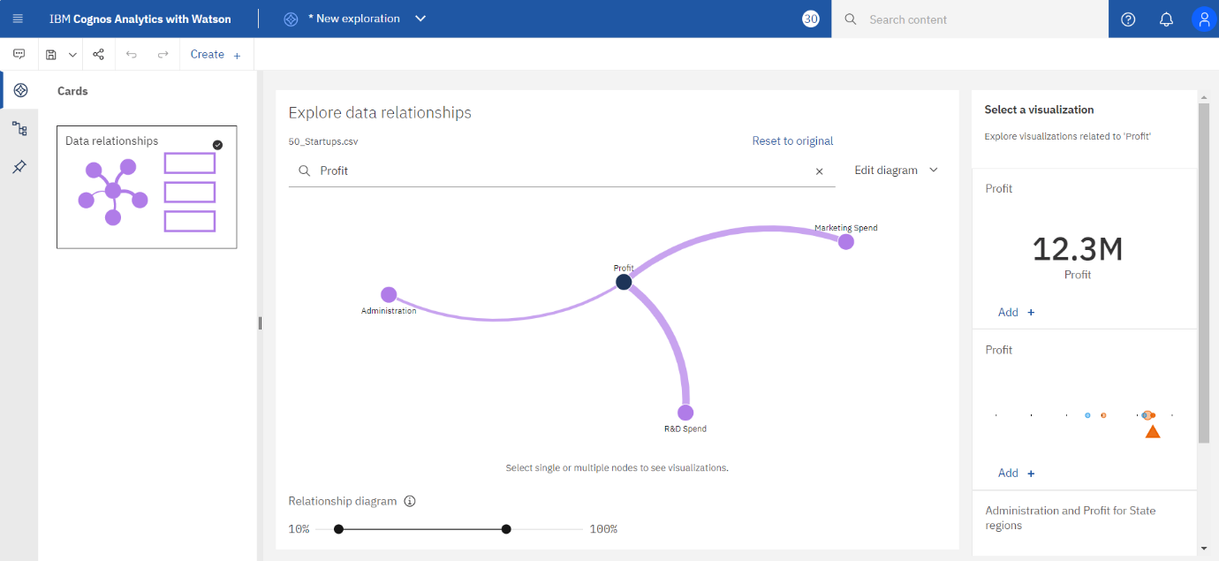

Explore Data Relationships – Marketing Spend

Explore Data Relationships – Administration

Explore Data Relationships – R & D Spend

Visualization – Bar Chart

Visualization – Pie Chart

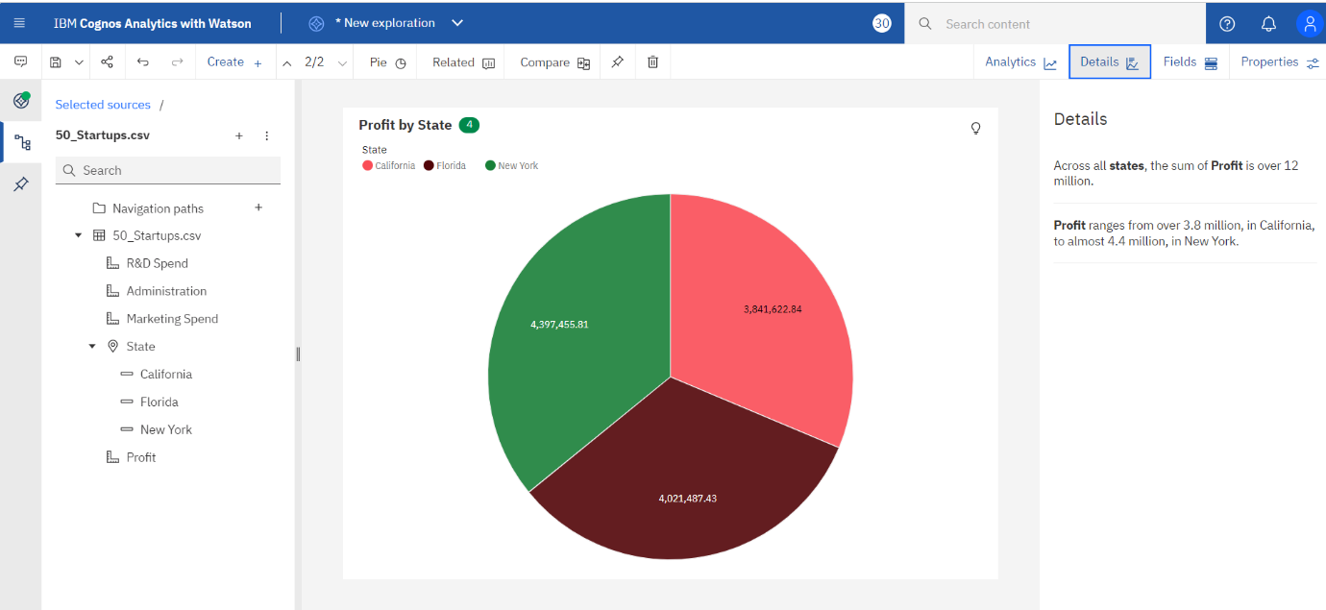

Visualization – Line

Visualization – CrossTab

